Sealing Lid Innovations by Greiner Packaging:
Sustainable, Leak-Proof, Flexible

With Click On and Click In, Greiner Packaging is launching two new sealing lids that not only simplify packaging processes but also set new standards in recycling and CO₂ reduction.

- A consistent mono-material solution that significantly improves recyclability
- The Click On impresses with its universal fit, making it a highly flexible lid for various cup shapes
- The Click In features an audible locking mechanism and provides maximum leak protection

Kremsmünster/Austria, July 10, 2025. Greiner Packaging is launching two innovative packaging solutions, the Click On and Click In sealing lids, designed specifically to meet the needs of environmentally conscious manufacturers and modern consumers. These products expand the existing portfolio with functional advancements that meet the highest standards of usability and sustainability.

Greater sustainability through fewer components
Sealing lids are based on a well-thought-out two-component principle: cup and lid. This allows for the deliberate omission of a third component, such as an aluminum foil. The key advantage is that both parts can be made from the same material, such as PP, PET, or r-PET. This mono-material approach increases recyclability and reduces CO₂ emissions across the entire value chain.

In addition, sealing lids are reclosable, making them ideal for larger-volume products that aren’t consumed all at once. The lid protects the product from external influences and helps extend shelf life. Greiner Packaging’s sealing lids are compatible with standard sealing technologies such as thermal and ultrasonic sealing and offer a wide range of customization options.

Click On Sealing Lid: One Lid to Fit Them All
The new Click On sealing lid from Greiner Packaging offers a flexible, user-friendly solution specifically designed to be used without any modification to the cup. Its straightforward application makes it a particularly versatile option for a wide range of packaging requirements. It ensures a secure hold, even if the cup tips over or is turned upside down. Moreover, the lid comes in two distinctive tab styles, offering versatile options.

Designed to be part of a sustainable mono-material system, the sealing lid, together with the cup, utilizes a single material to enhance recyclability. Compared to the conventional combination of snap-on lid and aluminum foil, this solution contributes to CO₂ reduction. As a result, the Click On combines reliable functionality with sustainable packaging design - a solution that fits in every way.

Click In Sealing Lid: One Click, Sealed Quick
The new Click In sealing lid from Greiner Packaging was developed specifically for applications where secure closure and reliable product protection are paramount. After the initial opening, the lid can be easily pressed back onto the cup. It audibly and tangibly locks into the rim of the cup. This clear feedback not only ensures user-friendly handling but, above all, a high level of leak protection, even during movement or transport. The innovative locking function requires only a small modification to the cup rim - a simple yet effective measure to ensure a secure fit.

The Click In sealing lid is suitable for thermoformed and injection-molded cups and, thanks to its smart design, offers a reliable and practical everyday solution that integrates seamlessly with the cup. Naturally, this version also follows the mono-material principle - for easy reintegration into the recycling loop.

Reimagining a Proven Concept
Greiner Packaging’s Standard sealing lid has been successfully in use for over 25 years - proven millions of times, efficiently produced, and still a popular classic today. It offers a reliable initial seal and is available in numerous sizes and shapes, from round to square, with various decoration options.
With the new Click In and Click On variants, Greiner Packaging once again demonstrates that true innovation often begins where existing solutions are improved, optimized, and developed further to meet new demands.

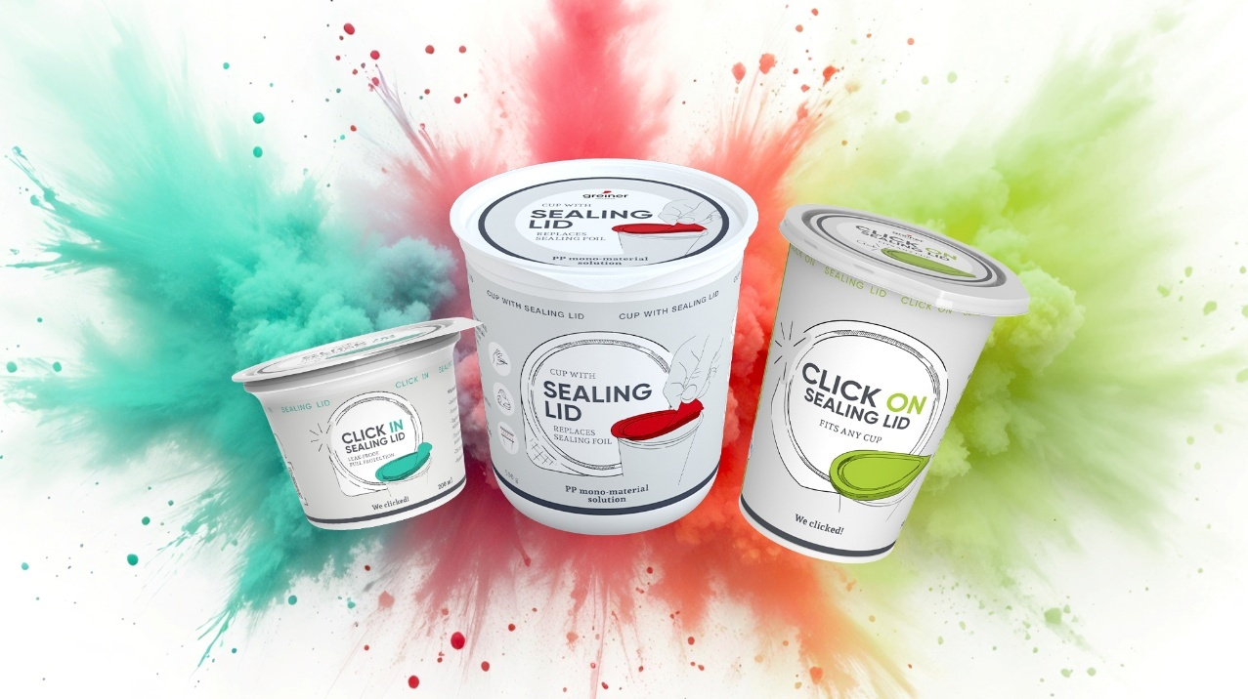
Suggested caption:
Three solutions, one principle: Click In, Click On, and the standard sealing lid combine sustainable mono-material design with reliable functionality - the right packaging for every requirement.
Credit: © Greiner Packaging

Text & images:
Text document as well as images in high-resolution quality for download:
https://greinerpackaging.canto.de/b/O13NM

About Greiner Packaging
Greiner Packaging helps global food, beverage and household brands stand out sustainably with plastic packaging solutions that don’t compromise on quality or feel. For more than 60 years, we’ve helped customers all over the world make an impact on the shelf - and the planet - with packaging solutions born from lightweight, sustainable materials and cutting-edge European design and innovation. This is best exemplified by our award-winning K3® - a revolutionary cardboard-plastic cup. With expert design and prototyping services, a wide range of production, material and decoration technologies, and 30 locations in 18 countries, Greiner Packaging is the ideal partner for bold brands who want to show the world their good side.
To learn more about Greiner & our packaging solutions, visit greiner-gpi.com.

Greiner Packaging Media Contact:
Peter Dobosz
Global Expert PR & Content Marketing

Greiner Packaging International GmbH
Gewerbestraße 15, 4642 Sattledt, Austria
Mobil phone: +43 664 4110735
E-mail: p.dobosz@greiner-gpi.com

